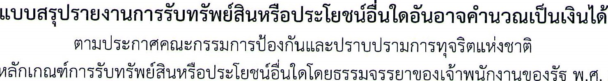· 2563
乚

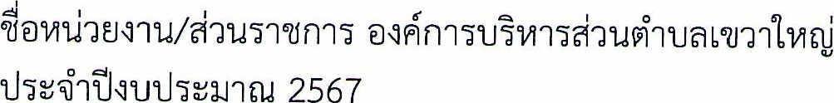
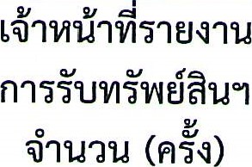 |  | 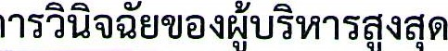
 | 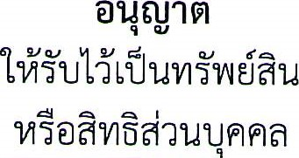 | 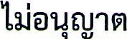
 |  | 7<flU10LfÄ  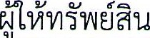 | 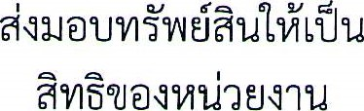
0 | 0 | 0 | 0
