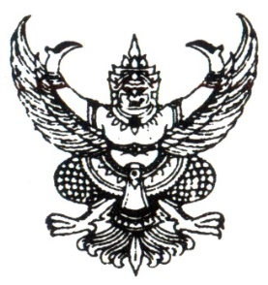

Announcement Khwaoyai Subdistrict Administrative Organization
Subject Policy of not accepting neither gifts from performing duties duties (No Gift Policy)
Fiscal year 2025
..........................................................................

Khwaoyai Subdistrict Administrative Organization has emphasized on managing organization with good governance to build faith and confidence in society that
Khwaoyai Subdistrict Administrative Organization is the good governance Organization I as the Chief Executive of the SAO, hereby declare and demonstrate my intention to perform duties and administer national affairs. I would perform my duties at the utmost of my ability with accountability, honesty and transparency in accordance with the guideline for promoting ethics and adhere to the principle of good governance.
I hereby pledge that all Khwaoyai Subdistrict Administrative Organization executives and Khwaoyai Subdistrict Administrative Organization officials have intention of not accepting neither gifts nor profits nor profits from performing our duties, both before and after performing our duties which would cause corruption and misconduct at the present and in the future. I would also stand against all forms of corruption to promote the honesty value and create an integrity organization culture in strong and sustainable ways
It is hereby announced and to adhered to all
This announcement is made on 2 January, 2025
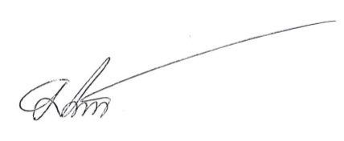

( Mr.Mongkol Numsrioun )
Chief Executive of the SAO
Khwaoyai Subdistrict Administrative Organization

